CALIFORNIA-NEVADA-HAWAI’I DISTRICT OF CIRCLE K INTERNATIONAL
2021-2022 DISTRICT ADMINISTRATION & OPERATIONS COMMITTEE APPLICATION
Dear Applicant,
Thank you for showing interest in the Administration & Operations Committee; I really appreciate your time and effort in checking this application out.
As a member of the A&O Committee, you will be working closely with me to act as a resource to the Vice Presidents of Administrations across the District, assist with special projects, and engage with the Alumni network. While it is recommended that applicants have prior experience with serving on club board and planning projects, it is by no means necessary! I’m hoping to find individuals who are driven and open to implementing new ideas in order to establish a solid foundation for A&O in the coming years!
This will be a very interesting term where you will have to adapt along with the District’s changing needs, especially as we recover from the COVID-19 pandemic. I look forward to reviewing your application, so please be sure to fill the application out to the best of your ability. All applicants will be reviewed thoroughly and professionally. Decisions will be made based on who is believed to be the most qualified and meets the needs and goals of this year's District Board.
With that being said, thank you again for your interest in applying for the Administration & Operations Committee and I wish you the best of luck on your application! Please do not hesitate to contact me if you have any questions throughout the entire process. I can’t wait to see what you will bring to table this year!
With love,
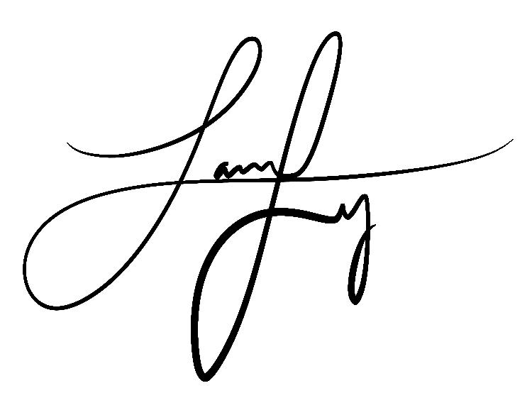
Jamie Ly
2021-2022 Administration & Operations Chair
ao@cnhcirclek.org

SECTION 1: ABOUT THE ADMINISTRATION & OPERATIONS COMMITTEE

The Administration & Operations Committee is to provide resources for the Vice Presidents of Administration across the CNH District to support their appointed board and general membership. Furthermore, the A&O Committee will assist in planning and implementing leadership development special projects as directed by the Committee Chair, District Governor and/or District Administrator.

GENERAL GOALS FOR THE 2021-2022 ADMINISTRATION & OPERATIONS COMMITTEE
- Improving outreach and providing support to Vice Presidents of Administration
- Encourage a positive environment and emphasis on mental health to clubs
- Implementing special projects to further District efficiency at the discretion of the committee chair, District Governor, and/or District Administrator
- Contribute to all discussions and projects of the committee
- Any additional goals decided upon by the committee, District Governor, and/or District Administrator

SECTION 2: APPLICATION TIMELINE

- Application process: Tuesday, May 4, 2021 to Monday, May 24, 2022.
- Applications must be submitted by Wednesday, May 19th 2021 at 10:00PM (PDT) / 10:00PM (HST) to Administration & Operations Chair Jamie Ly (ao@cnhcirclek.org) and District Governor Ryan Tan (governor@cnhcirclek.org).
- Applicants invited to an interview will be notified Thursday, May 20th, 2021.
- Interviews will take place Thursday, May 20, 2021 to Sunday, May 24th, 2021.
Appointments will be made by Monday, May 24, 2021. All applicants will be notified of final selections by then.

SECTION 3: RESPONSIBILITIES

The members of the District Administration & Operations Committee are responsible for:
- Being a resource for the Vice Presidents of Administration and club boards
- Creating and updating effective resources for club board health and relations
- Assisting with the planning and implementation of special projects

The following is a list of minimum responsibilities expected of each committee member. Please indicate that you have read and understand the duties by double clicking and checking the boxes.
☐ Attend ALL committee meetings unless excused with a valid reason and 24 hours advance notice. Meetings will generally be held online.
☐ Participate actively in committee meetings by brainstorming ideas, providing input and feedback to the committee as a whole in an advisory role and voting member of the committee, and helping other committee members with or without being asked.
☐ Remain in constant communication with the Administration & Operations Chair by reporting activities and progress through check-ins.
☐ Complete all assigned projects early or ON TIME. If you require an extension of need assistance with a task, contact the Administration & Operations Chair in a timely manner.
☐ Maintain transparency and communication with clubs by researching the needs of club boards, collecting diverse ideas to share with VPAs, and being supportive and actively communicative towards the clubs you work with.
☐ Be open and willing to learn and contribute to the A&O Committee.
☐ Represent Circle K International in a professional manner.

SECTION 4: POSITIONS & REQUIREMENTS

POSITION DESCRIPTIONS
The following is a list of the minimum duties for each of the position:

Special Projects Assistant
The Special Projects Assistant will aid the committee chair with the following items:
- Assist the committee chair with the development and implementation of professional development events
- Providing feedback and direction to special projects
- Develop related resources necessary to assist clubs with acclimating to new project implementation
- Complete any other duties as assigned by Committee Chair

IN ORDER TO APPLY, YOU MUST MEET THE FOLLOWING REQUIREMENTS:
- Be a dues-paid member of a club in good standing.
- Be enrolled at least half-time during the 2021-2022 term.

SECTION 5: CONTACT INFORMATION

GENERAL INFORMATION
First Name: | Last Name:
Phone Number: | Text? (Y/N)
E-Mail: | Club & Division:
Years in Circle K:
ACADEMICS
School: | Major:
Year in College:
MISCELLANEOUS
Other committees that you are applying for (State which positions if applicable):

SECTION 6: GENERAL QUESTIONS

Please provide a brief response to the following questions FOR EACH POSITION YOU LISTED ABOVE:
Describe your involvement in Circle K and how it qualifies you for the position(s) which you are seeking. List any past experience that will help you in the position(s) you are applying for.
Why do you want to be a part of the committee and why do you want the position(s) you are applying for?
List any other commitments (both inside and outside of Circle K) that you will have from now until March 2022 and the hours you will spend per week doing them. Explain how you prioritize these commitments.
Are you applying for any other District Committees this term? If so, which one(s)?
What are two unique ideas you have for the committee?

SECTION 7: POSITION-SPECIFIC QUESTIONS

* Please answer your position(s’) specific questions in the provided space on the next page of the application *

SPECIAL PROJECTS ASSISTANT
- How familiar are you with event planning and project management? What experience do you have with creating and implementing new projects?
- What does professional development mean to you? What do you believe is the most important aspect of professional development?
- How will you assist the other officers in this committee outside of your own responsibilities?

Please use the space provided below to answer the question(s) that pertain to the position(s) you are applying for. Feel free to use as much space as you need, but please be concise with your answers.

SECTION 8: REFERENCES

Please provide at least two references and their contact information. These references can be Circle K members, officers, or advisors, or people you have worked with professionally that can attest to your work ethic and professionalism.

REFERENCE 1
Name
Title
Email
Phone

REFERENCE 2
Name
Title
Email
Phone

SECTION 9: INTERVIEW AVAILABILITY

The second round of this application process will be an interview with the District Secretary. Each interview is expected to last no more than 20-30 minutes and will be conducted via Zoom. An email containing a Zoom link will be sent 15 minutes before each interview. You will be contacted with a final interview date and time by Sunday, May 16th, so please make sure to check your email by then to confirm the time.
Though not everyone may get an interview, please provide your tentative availability for an interview in the case that you do move onto to the next round. Please indicate ALL times at which you will be available from 8:00AM-10:00PM on the days listed below.

Thursday, May 20th, 2021
Friday, May 21st, 2021
Saturday, May 22nd, 2021
Sunday, May 23rd, 2021

SECTION 10: SUBMISSION & CERTIFICATION

Thank you for completing the 2021-2022 California-Nevada-Hawai’i District Club Administration * Operations Committee Application! Please remember to fill out the boxes below.
E-Signature (Print Name) |  | Date

Please complete this application and email it to:
Jamie Ly
Administration & Operations Chair
ao@cnhcirclek.org
&
Ryan Tan
District Governor
governor@cnhcirclek.org

Please send the application in PDF format with the application file and email subject line in the following manner:
A&OCommittee_FirstNameLastName (e.g. A&OCommittee_JamieLy)

Please feel free to contact me if you have any questions!

All applications are to be RECEIVED by
Wednesday, May 19th, 2021 by 10:00 PM (PDT)/10:00 PM (HST)

Thank you for your interest in becoming a part of the 2021-2022 District Administration & Operations Committee!

This concludes the California-Nevada-Hawai’i District Administration & Operations Committee application.

