California-Nevada-Hawai’i District
Circle K International
Member Recognition Committee Application
2018-2019

Dear Applicant,
Thank you for your interest in the District Member Recognition Committee! Circle K International fosters selflessness through service. The California-Nevada-Hawai’i District of Circle K International is comprised of individuals, clubs, and divisions that go above and beyond in their dedication to the tenets of service, leadership, and fellowship. This year, I’m looking for individuals who are passionate, innovative, and dedicated to recognizing others for all that they do for this organization. The committee will aim to promote forms of member recognition such as District Awards and the Membership Recognition Program (MRP) as guidelines for members and clubs to maximize their achievements. In addition, the committee will aim to promote and create additional outlets for recognition at the District level and help clubs and divisions implement and improve their own recognition programs.
Member recognition ushers in a sense of fulfillment and a sense of pride for our district’s amazing accomplishments. Member recognition has the potential to encourage involvement, ignite passion, and promote growth in the clubs and members of Circle K. Thus, the Member Recognition Committee will play a crucial role in enhancing the member and club experience.
Please make sure to read the entire application before filling it out. All applicants will be reviewed thoroughly and professionally. Decisions will be based on who is believed to be the most qualified and meets the needs and goals of this year’s District Board. Throughout the process, remember that I want to get to know you and see what you can bring to the committee. Please do not hesitate to contact me if you have any questions, comments, or concerns. I wish you the best of luck!
Sincerely,
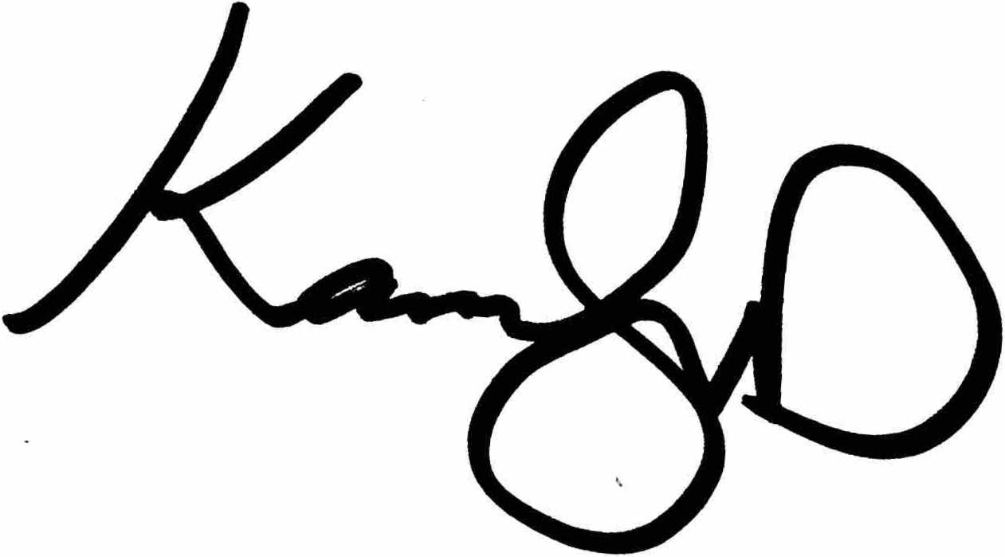
Katelyn Duch
2018-2019 District Member Recognition Chair
member-recognition@cnhcirclek.org
Application Timeline:
- Application process: Wednesday, April 25, 2018 to Friday, May 18, 2018.
- Applications must be submitted by Wednesday, May 9, 2018, 10:00PM (PST) / 7:00PM (HST) to District Member Recognition Chair, Katelyn Duch (member-recognition@cnhcirclek.org) and District Governor, Manuel Santiago (governor@cnhcirclek.org).
- Applicants invited to an interview will be notified by Friday, May 11, 2018.
- Interviews will take place Saturday, May 12, 2018 to Wednesday, May 16, 2018*.
- Appointments will be made by Wednesday, May 18, 2018*. All applicants will be notified of the final selections.

* Dates may change based on the discretion of the chair.

Responsibilities:
The purpose of the District Member Recognition Committee is to encourage and promote recognition throughout the California-Nevada-Hawai’i District. This recognition encompasses District Awards, the Membership Recognition Program (MRP), and club and member spotlights such as Member Recognition Mondays. The committee will also aim to help clubs and divisions implement and improve their own recognition programs. The members within this committee are expected to fulfill these tasks and to provide input to the District Member Recognition Chair as well as organize and attend committee-planning events. The following is a list of minimum responsibilities expected of each standing committee member.

Attend online committee meetings set by the Member Recognition Chair. Must also attend any in-person meetings set by the Member Recognition Chair (within reason). For any missed meetings, it is understood that the Member Recognition Chair be notified in a timely manner prior to the scheduled meeting.
Actively participate in committee meetings by brainstorming ideas, providing input and feedback to the committee as a whole in an advisory role and voting member of the committee.
Remain in constant communication with the District Member Recognition Chair reporting activities and progress through check-ins.
Complete all assigned projects ON TIME. If this is not possible, the District Member Recognition Chair will be notified in a timely manner.
Serve as a representative for your home club, Division, and the District as a whole by actively encouraging clubs and members to apply for awards and participate in the Membership Recognition Program (MRP).
Attend both the CNH Circle K Fall Training Conference and the CNH Circle K District Convention. For extreme cases, it is understood that the Member Recognition Chair be notified in a timely manner prior to the event.
Be willing to help with any and all tasks pertaining to the improvement and participation of awards, the Membership Recognition Program (MRP), the Master Records Sheet (MRS), and other potential opportunities for member recognition throughout the District, especially at District events.
Please note that you have read the duties by double clicking and checking the box. Being a part of the Member Recognition committee is not to be taken lightly and will require time on your part to make this a successful running committee. Attention to detail, frequent communication and adhering to deadlines is essential for all positions.

- All members of the committee are expected to:
- Help improve and promote District Awards and the Membership Recognition Program (MRP) to the Cal-Nev-Ha District as guidelines for clubs and members to maximize their achievements
- Edit and update any past awards and resources, such as manuals, after the approval of the District Awards Proposal
- Foster innovative opportunities for member recognition at the District level including but not limited to Member Recognition Mondays
- Create transparency by communicating with members on the committee’s activities
- Represent Circle K International in a professional manner

If appointed, committee members will complete a service agreement form that ensures they are aware of and will adhere to all responsibilities and expectations set forth for the District Member Recognition Committee.

Position Descriptions:
Executive Assistants (2):
Two Executive Assistants will be appointed to the District Member Recognition Committee – one Administrative Executive Assistant and one Creative Executive Assistant. Both Executive Assistants will help the District Member Recognition Chair manage the District Member Recognition Committee when needed and complete the specific tasks assigned to their respective positions.

- Administrative Executive Assistant:
The Administrative Executive Assistant will be responsible for assisting the Membership Recognition Program/Master Records Sheet (MRP/MRS) Coordinator with updating the list of MRP recipients after Master Records Sheet bi-monthly check-ins and making the MRP slideshows for Fall Training Conference and District Convention. Thus, they must have experience working with Microsoft Excel and PowerPoint. If the District Member Recognition Chair cannot attend or facilitate a meeting or member recognition-related event, the Administrative Executive Assistant will be asked to step in. In addition, the Administrative Executive Assistant will work with other committee members to hold webinars on recognition-related topics at least once every two months. Administrative Executive Assistant duties may be subject to change by the District Member Recognition Chair.

- Creative Executive Assistant:
The Creative Executive Assistant must possess avid skills in graphic design to create promotional materials for the District Member Recognition Committee. They will be responsible for designing manuals, awards certificates, and graphics including but not limited to Member Recognition Mondays and Member Features. Creative Executive Assistant duties may be subject to change by the District Member Recognition Chair. Creative Executive Assistant applicants must attach 3 to 5 supplemental creative samples to spotlight past work (graphics, manuals, certificates, etc.).

Divisional Liaisons (3):
Three Member Recognition Division Liaisons will be appointed to the District Member Recognition Committee. Each liaison will be assigned three CNH District Circle K Divisions to represent as follows:

- Northern Representative: Capital, Golden Gate, Sunset
- Central Representative: Central Coast, Desert Oasis, Foothill
- Southern Representative: Magic Kingdom, Metro, Paradise

As an official Member Recognition Liaison, they will keep in constant communication with the Lieutenant Governors within their assigned Divisions regarding updates with awards, the Membership Recognition Program, deadlines, nominees for Member Recognition Mondays, and other information pertinent to the work of the committee. The Divisional Liaison will hold one-on-ones with club officers twice in the term, once in the summer and once towards the end of the term. The first to help clubs implement and/or improve their recognition program(s) and help clubs understand how to maximize their achievements using past awards and the Membership Recognition Program and the second to help clubs reflect on their recognition program(s), motivate clubs to apply for awards, and provide guidance on awards. Lastly, the Divisional Liaison will work with the Administrative Executive Assistant to hold at least one recognition-related webinar every two months. The Divisional Liaison must be an individual who is responsible, organized, and has the ability to work well with others. Divisional Liaison duties may be subject to change by the District Member Recognition Chair.

Membership Recognition Program/Master Records Sheet Coordinator (1):
The Membership Recognition Program and Master Records Sheet Coordinator will work with the District Member Recognition Chair to update the Master Records Sheet after the approval of the District Membership Recognition Program Proposal. In addition, the coordinator with provide feedback to club officers on their Master Records Sheet during bi-monthly MRS check-ins. Thus, they must have extensive knowledge in Excel and must be able to troubleshoot any potential issues with formulas and formatting in the Master Records Sheet. Lastly, the coordinator will educate members on the Membership Recognition Program and recognize members who have achieved a MRP standing at Fall Training Conference and District Convention. The coordinator must be an individual who is responsible, detail-oriented, organized, and has the ability to work well with others. The coordinator duties may be subject to change by the District Member Recognition Chair.

IN ORDER TO QUALIFY FOR THE DISTRICT MEMBER RECOGNITION COMMITTEE, YOU MUST MEET THE FOLLOWING REQUIREMENTS:
- Be a dues-paid member of a club in good standing.
- Be enrolled at least half-time during the 2018-2019 term.
- Have an interest in recognizing individuals of the California-Nevada-Hawai’i District for their dedication to Circle K International and the tenets of the organization.
- Have at least basic knowledge of Microsoft Excel.
Contact Information:
Name |  | Phone Number
School/Division |  | Texting? (Y/N)
Major/Year |  | Email
Position(s) of Interest | 1.
 | 2.
 | 3.
References:
Please provide two references and their contact information. These references can be Circle K members, officers, or advisors, or people you have worked with professionally that can attest to your work ethic and professionalism.
Name
Title
E-mail
Phone Number

Name
Title
E-mail
Phone Number

Short-Answer Questions:

Why do you want to be a part of the District Member Recognition Committee? Why do you want the position(s) you are applying for? What do you hope to gain from this experience?
List any past experience that will help you in the position(s) you applied for.
What is your vision for the role of the District Member Recognition committee, and what do you believe we can realistically implement this upcoming term?
Have you completed a CNH District Awards Application before? If yes, which award did you apply for and what are some ideas for improvement you have pertaining to it?
If you could remove one award, which would it be and why? If you could add one award, what would it be and why?
Describe your familiarity with the Membership Recognition Program (MRP) and Master Records Sheet (MRS). What improvements would you make regarding the two?
Member recognition extends beyond awards and the Membership Recognition Program (MRP). What ideas do you have to continue programs to recognize the members and clubs of this district throughout the year?
Fall Training Conference 2018 and District Convention 2019 will take place at hectic times of the semester/quarter. These events occur around midterms season and/or finals season for most schools. What will your potential workload be leading up to these events? How will you manage your time to ensure that you can thoroughly fulfill committee duties for these events?
List any other commitments (both inside and outside of Circle K) that you will have from now until March 2019 and the hours you will spend per week doing them.
Are you applying for any other District committees this term? If so, which one(s)?

Finally, please answer the following prompt. Write as much or as little as you want, as long as your answer is complete and well thought out.
One of the goals of the District each year involves encouraging clubs to strive to maximize their achievements. Every year, the District wants to utilize awards and the Membership Recognition Program (MRP) to motivate clubs to grow – in membership, service hours, club hosted events, interclub events, and more. How would you actively promote these forms of member recognition to clubs throughout the entire District, especially to smaller clubs? What additional requirements, if any, would you like to see on the awards and/or Membership Recognition Program (MRP) this year?

Possible Interview Times:
The second round of this application process will be an interview with the Member Recognition Chair. Though not everyone may get an interview, please provide your tentative availability for an interview in the case that you do move onto to the next round. Please indicate ALL times at which you will be available from 8:00AM-10:00PM on the days listed below.
Saturday, May 12th, 2018
Sunday, May 13th, 2018
Monday, May 14th, 2018
Tuesday, May 15th, 2018
Wednesday, May 16th, 2018

Please do not hesitate to contact me if you have any questions, comments, or concerns. I look forward to reading your application.
Good luck!

Please send the application to BOTH the District Member Recognition Chair and District Governor in PDF format with the application file and e-mail subject line in the following manner:

MRCommittee_FirstNameLastName (eg. MRCommittee_KatelynDuch)
Late applications will NOT be accepted.

Katelyn Duch
District Member Recognition Chair
member-recognition@cnhcirclek.org

Manuel Santiago
District Governor
governor@cnhcirclek.org

All applications are to be RECEIVED by
May 9, 2018 by 10:00 PM (PST) / 7:00PM (HST)!

Thank you for your interest in becoming a part of the 2018-2019 District Member Recognition Committee!

This concludes the California-Nevada-Hawai’i District Member Recognition Committee application.

