CALIFORNIA-NEVADA-HAWAII DISTRICT
Circle K International
Membership Development & Education Committee Application
2019–2020

Dear Applicant,

Thank you for your interest in applying for the District Membership Development & Education Committee! I appreciate your eagerness and dedication in becoming more involved on the District level, especially in improving one of the core aspects of Circle K: our members. I highly recommend applying because an enriching experience such as this will have great outcomes for both your path in Circle K and in life. As such, I hope to find individuals who are willing to explore beyond their comfort zone and execute their creative innovations on the committee, thus producing the best experience possible for the members of our California-Nevada-Hawai'i District.

In this application, I hope to have a better understanding of you as an applicant and individual, and of your goals for both the committee and district. Please duly read through the entire application and fill out all sections required. If you have any questions or comments regarding any section of the application, please do not hesitate to contact me.

All applicants are to be reviewed professionally, selections based on who will be able to fulfill the objectives of the committee and District Board. Do note that the positions and duties described in this application may change at the discretion of the committee chair.

I thank you so much for taking one step forward in nurturing your Circle K experience. Best of luck to you!

Warmest regards,
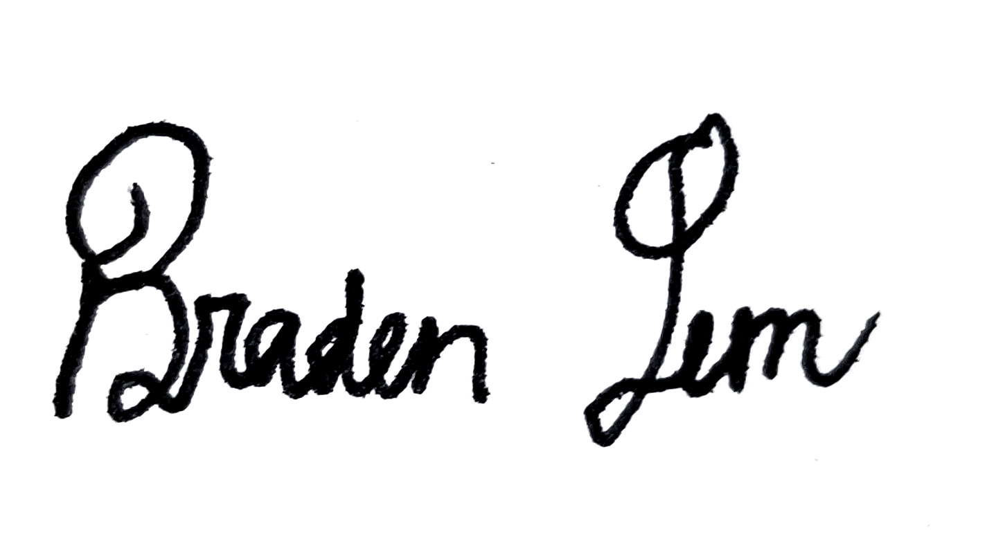
Braden Lem
2019–2020 District Membership Development & Education Chair
Application Timeline

- Application process: Monday, May 13, 2019 to Friday, May 24, 2019.
- Applications must be submitted by Friday, May 17, 2019 at 10:00PM (PST) / 7:00PM (HST) to District Membership Development & Education Chair Braden Lem (mde@cnhcirclek.org) and District Governor Wayne Cheng (governor@cnhcirclek.org).
- Applicants invited to an interview will be notified by Saturday, May 18th, 2019.
- Interviews will take place Sunday, May 19, 2019 to Wednesday, May 22, 2019*.
- Appointments will be made by Friday, May 24, 2019*. All applicants will be notified of final selections by then.

* Dates may change based on the discretion of the chair.

Responsibilities and Expectations

The purpose of the Membership Development & Education, or MD&E, Committee is to provide educational resources for usage by all members of the district. This includes but is not limited to membership resources—concerning member recruitment, retention, involvement—and member education regarding various components of Circle K International as well as professionalism.

The following is a list of minimum responsibilities expected of each member of the Membership Development & Education Committee:

Attend all online committee meetings agreed upon by the committee and any in-person committee meetings set by the membership unless excused with a valid reason and within a timely manner. Committee meetings will generally be held online.

Participate actively within the committee by
    - Brainstorming new ways of promoting member education and development within the district, and
    - Assisting in the creation of programs for clubs to implement in recruitment, retention, education, and professional development.

Remain in constant communication with the chair by reporting activities and progress through check-ins and one-on-one’s facilitated by the chair.

Complete all assigned projects ON TIME. If this is not possible, notify the chair in a timely manner.

Maintain transparency as a District Committee member by
    - Attending several, if not all, district-held events to show support for District Board, and
    - Communicating with clubs and divisions in the district to receive feedback from members about how the District Board could improve future events.

Maintain constant communication with the clubs you represent by
    - Researching how different types of clubs succeed in recruitment and retention and using that information to help the clubs that need support,
    - Collecting diverse ideas to share with clubs, and
    - Being supportive and actively communicative towards the clubs that you work with.

Failure to complete any of these tasks will result in a warning. Further failure may result in removal from the committee at the chair’s discretion.

Please note that you have read the duties by double clicking and checking each box. Being a part of the Membership Development & Education committee is of a serious manner and will require dedication to make this a successful and efficient committee. Attention to detail, frequent communication and adhering to deadlines is essential for all positions.

All members of the committee are expected to
- Help develop and publish successful resources intended for CNH Circle K,
- Encourage membership development and education for ALL clubs,
- Communicate with members about the committee’s activities,
- Contribute to all discussions and projects of the committee, and
- Represent Circle K International in a professional manner.

Committee Positions and Descriptions

Executive Assistant (1)
- Serve as the standing chair when the chair is not present.
- Assist the chair in overseeing the activities of the committee and ensuring all committee members are aware of their duties and deadlines.
- Assume any tasks not specifically designated to any committee member.
- Record and distribute committee meeting minutes.
- Develop an efficient method to promote network and support for Membership Development & Education officers and Vice Presidents of Administration.
  - If there are clubs that do not have these officers, incorporate an officer that would focus on that aspect (e.g. President).
- Develop and promote the district-wide Sunny Buddies program, which connects members across the district in a pen pal system.
- It is preferred but not required that the Executive Assistant has previously served on the Membership Development & Education committee.

Creative Director (1)
- Assist committee with producing designs for resources and manuals.
- Collaborate with the committee on what designs are necessary throughout the term for resources and Membership Development & Education events.
- Promote the utilization of resources to the targeted audience.
- Collaborate with the District Technology Chair to ensure resources are made available through the District Website.
- All applicants must submit a portfolio of graphics and publications as supplement to their application.

Webinars Coordinator (1)
- With the help of the committee, determine which topics should be presented that promotes professional and membership development.
- Assist the Membership Development & Education Chair in establishing monthly webinars.
  - Find and recruit monthly webinar hosts.
  - Assist the host(s) with their webinars throughout the term.
  - Gather evaluation for more efficient ways to present webinars and other topics members would like to see.
- Responsible for providing members with educational and impactful workshops during District Professional Development Conference.

Resources Coordinator (2)
- With the help of the committee, lead the production of resources that will benefit all clubs in the district.
  - Create outlines of resources being produced and address these points to the rest of the committee at meetings.
- Organize resources in an efficient way that would be readily accessible for the district.
  - Collaborate with the Lieutenant Governors on ensuring every club is given the opportunity to retrieve these resources.

Professional Development Coordinator (1)
- Assist the Membership Development & Education Chair in assisting with developing a professional directory consisting of contact of professionals and professional organizations.
- Lead the development of professionalism in the district by incorporating ideas such as expos, mock interviews, webinars, professional databases, and professional development events.
- Develop and promote the district-wide Alumni Mentorship system to connect members with district alumni and Kiwanians.

Prerequisites

IN ORDER TO APPLY TO THE DISTRICT MEMBERSHIP DEVELOPMENT & EDUCATION COMMITTEE, YOU MUST MEET THE FOLLOWING REQUIREMENTS:
1) Be a dues-paid member of a club in good standing.
2) Be enrolled at least half time during the 2019–2020 term.

Contact Information

Name |  | Phone Number  (Text: Y/N?)
Club/Division |  | E-mail

Past and Current
Positions Held
Other committees you are applying for (State which positions if applicable)
Positions of Interest

References

Please list up to two references and their contact information—name, number, email. they can be Kiwanis Advisors, officers, members, or people you have worked with professionally that can attest to your work ethic and professionalism.

Name
Title/Affiliation to Applicant
E-mail
Phone Number

Name
Title/Affiliation to Applicant
E-mail
Phone Number

Short-Answer Prompts

Please provide a brief response to each of the following questions.

1. Why do you want to be a part of the District Membership Development & Education Committee? What do you hope to gain from this experience?
2. What qualifications do you have to be on the District MD&E Committee? List any experiences and skills that will help you both with general responsibilities, as well as the specific position(s) you indicated.
3. Describe the member recruitment and retention obstacles a club may generally face, and list viable strategies to resolve these obstacles.
4. Why is professionalism relevant to Circle K members? How do Circle K alumni and Kiwanians play a role in professional development? What are some strategies that can be implemented to promote professional development in the district?
5. What makes a resource most effective in conveying information to the consumer? Remark on digital manuals, online webinars, and district-wide workshops; how can the quality of these previously mentioned resources be maintained or improved?
6. What improvements do you think the CNH District of Circle K and District MD&E Committee should make? How can we implement these ideas?
7. What are some SPECIFIC goals you have in mind for this year’s committee and the position you are interested? Please describe how the committee would achieve these goals.
8. What commitments do you anticipate for next year? Please note approximate hours per week (Circle K, school, work, etc.) where appropriate. How will you balance these commitments throughout the term?

Interview Times

The second round of the District MD&E Committee Application involves a 10 to 15-minute interview between the chair and applicant. Applicants that will be receiving an interview will be duly notified by Monday, May 13th via email.

Though it is not guaranteed that each applicant will move on to the second round, please mark your tentative availabilities for an interview below in the case that you do move on to receive one. Please indicate all times of availability from 8AM to 10PM for each day listed.

Tuesday, May 14
Wednesday, May 15
Thursday, May 16
Friday, May 17
Saturday, May 18
Sunday, May 19

If you have any questions or comments, please do not hesitate to contact me. I look forward to reading your application.

Best of luck!

Please send the application by e-mail to BOTH the District Membership Development & Education Chair and District Governor in PDF format with the application file and e-mail subject line in the following manner:

MD&ECommittee_FirstNameLastName
(e.g. MD&ECommittee_BradenLem)

Braden Lem
District Membership Development & Education Chair
mde@cnhcirclek.org

Wayne Cheng
District Governor
governor@cnhcirclek.org

All applications are to be received by
SUNDAY, MAY 12TH, 2019 10PM (PST), 7PM (HST).

LATE APPLICATIONS WILL NOT BE ACCEPTED.

Feel free to attach any files that you feel will best supplement your application.

Thank you for your interest in becoming a part of the 2019–2020 District Membership Development & Education Committee!

This concludes the California-Nevada-Hawaii District Membership Development & Education Committee application.

